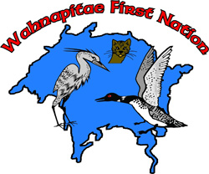

Wahnapitae First Nation











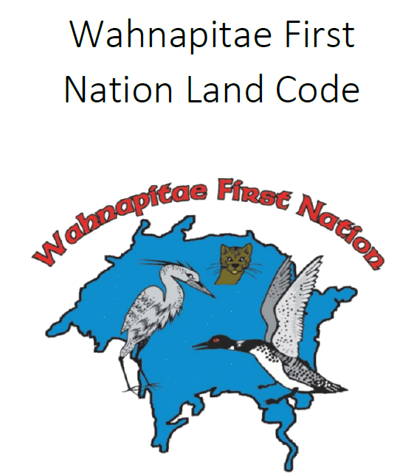





For more information, please contact Katie Ede, Lands and Resources Assistant at katie.ede@wahnapitaefn.com or by phone (705)858-0619
www.wahnapitaefirstnation.com
Part 1: Preliminary Matters
Definitions, Purpose
Part 2: First Nation Legislation
Law Making, Enforcement
Part 3: Community Meetings and Approvals
Participation, Procedures
Part 4: Protection of Land
Acquisition, Land Exchange
Part 8: Dispute Resolution
Process, Panel, Powers of the Panel
Part 7: Interests and Licences in Land
CPs, Leases, Transfers, Residency, MRP
Part 6: Land and Natural Resource Administration
Land Staff, Committee
Part 5: Accountability
Financial Management and Reporting to MCFN
Part 9: Other Matters
Offences, LC Revisions
The Land Code will be the basic Land Law of Wahnapitae First Nation. It sets out the broad general principles, vision, culture, customs, traditions and administrative structure for our reserve lands and resources.
Land Code Summary


Part 1: Preliminary Matters
This section explains the key terms used in the Land Code, where Wahnapitae’s authority to govern comes from, the purpose of the Land Code, and what lands it applies to. The Land Code applies to Wahnapitae Indian Reserve No. 11 and any future reserve lands added.
Part 2: First Nation Legislation
This part outlines Council’s law making powers over Wahnapitae First Nation Land. Council may make Land Laws respecting land use, zoning, environmental protection, development, interests and licences, and other land matters. Wahnapitae First Nation will have the authority to enforce its Land Laws.
Part 3: Community Meetings and Approvals
Land Laws and other important land matters must receive community input, and some require community approval. Every member has the right to be informed. Every eligible voter (18+ years) can participate in community approval processes and ratification votes. Community approval is required for major matters such as master land use plans, long term land grants or dispositions, non-renewable natural resource agreements, land exchanges, and deletion of heritage sites. Amendments to the Land Code require a ratification vote.
Part 4: Protection of Land
This part outlines some of the key protections the Land Code offers. Wahnapitae First Nation may expropriate an interest or licence only for a necessary community purpose and only after making a good faith effort to reach an agreement. Fair compensation must be paid. The Land Code protects against loss of reserve land. A land exchange must meet strict conditions, including community approval, equal or greater land size, comparable value, and reserve status.
Part 5: Accountability
Council is accountable to Members for the management of finances, land and natural resources under the Land Code. An annual report will be prepared and made available to Members. Conflict of interest rules apply to Council, staff, Lands Committee members and Dispute Resolution Panel members.
Part 6: Land and Natural Resources Administration
Council may delegate administrative authority to staff to carry out functions necessary for day-to-day administrative operations related to lands and natural resources. A Lands Committee will be established to support land administration, advise Council, assist with Land Law development, and support community consultation and approval processes.
Part 7: Interests and Licences in Land
This part explains how land interests (such as Certificates of Possession, leases, permits and easements) are granted, registered and transferred. All existing interests will continue after the Land Code comes into effect. New interests and licences will be granted under the Land Code. This section also outlines land allocation to Members, transfers between Members, limits on mortgages and seizures, residency and access rights, transfers upon death, and the authority to develop a Family Homes and Matrimonial Interests Land Law.
Part 8: Dispute Resolution
The dispute resolution process ensures that all persons who use or occupy Wahnapitae First Nation Land do so respectfully and in accordance with the Land Code. Disputes may move through discussion, negotiation, mediation and arbitration. A Dispute Resolution Panel will hear matters within its authority and issue binding decisions.
Part 9: Other Matters
The summary conviction provisions of the Criminal Code apply to offences under the Land Code, unless some other procedure is provided for by a Land Law.

