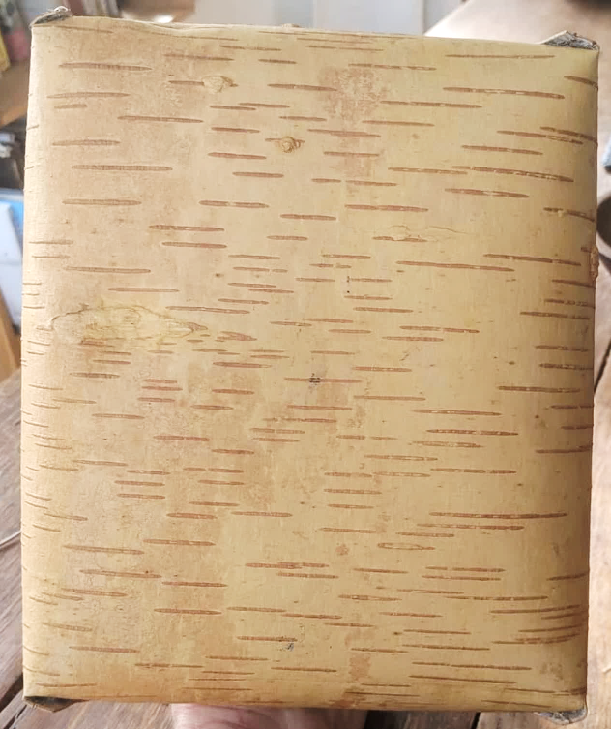





Background
In June 2021, Wahnapitae First Nation became one of 218 First Nations who are a party to the Framework Agreement on First Nation Land Management (“Framework Agreement”). The federal government is also a party to the agreement and ratified it through the Framework Agreement on First Nation Lands Management Act, S.C. 2022, c.19, s.121.
The Framework Agreement and legislation enable First Nations to take control over the management and administration of their reserve lands from Indigenous Services Canada (ISC). In order to do this, each First Nation must enter into an Individual Agreement with ISC. This Individual Agreement sets out the specifics of the transfer of management of reserve lands from Canada to Wahnapitae First Nation.
The Individual Agreement has 12 sections and 7 attached documents which are called Annexes.

Section 1. Interpretation
This section defines terms used in the Individual Agreement, including identifying Wahnapitae First Nation Land as the reserve lands that the Land Code will apply to.
Section 2. Information Provided by Canada
This section sets out the information provided by Canada. This includes a list of interests (such as permits, CP's and leases) and known environmental issues on the First Nation’s reserve lands. The lists of interests are set out in Annex “C”.
Annex “E” confirms that there is no additional material information to report.
Annex “D” includes a Phase I Environmental Site Assessment completed in December 2023. The report identifies areas of potential environmental concern and provides recommendations for further investigation and best management practices.
Section 3. Transfer of Land Administration
Canada will transfer land administration and management to Wahnapitae First Nation when the Land Code comes into force. Wahnapitae First Nation will then reclaim management and control of the reserve land and natural resources through the Land Code.
Section 4. Acceptance of Transfer of Land Administration
As of the date the Land Code comes into force, the 44 land management provisions of the Indian Act as listed in the Framework Agreement will no longer to apply to Wahnapitae Reserve No. 11.
Wahnapitae First Nation will begin governing its reserve land under the Land Code.

Note: Canada will remain liable for and will indemnify the First Nation for losses suffered as a result of any act or omission by Canada, or its agents, that occurred before the Land Code comes into effect.
Section 5. Operational Funding
Canada is obligated to provide annual funding for managing the reserve lands.
The funding amounts set out in Annex “A” are:
- $355,718 for the 2025–2026 fiscal year (prorated based on when the Land Code comes into force), plus $100,000 one-time Transitional Funding in the first year.
- $362,833 for the 2026–2027 fiscal year, plus $100,000 one-time Transitional Funding in the second year.
- Operational funding will continue after 2027, and increase by 2% annually.
Section 6. Transfer of Moneys
Canada must transfer to Wahnapitae First Nation any revenue and capital moneys it holds for the use and benefit of the First Nation, after the Land Code comes into force.
As of February 18, 2026, Canada is holding:
- $335,338.85 in revenue moneys
- $60,373.71 in capital moneys
Section 7. Notice to Third Parties of Transfer of Administration
If Members vote in favour of the Land Code and Individual Agreement, we must notify all non-members who have a legal interest in reserve land (such as utility permittee). The notice will inform them that Wahnapitae First Nation is taking over land management.
Section 8. Interim Environmental Assessment Process
Until Wahnapitae First Nation develops our own Environmental Assessment process, the interim process is intended to be broadly consistent with the requirements of the federal environmental assessment process. The interim process for Environmental Assessments is set out in Annex “F”.
Section 9. Amendments
The Individual Agreement can be amended in writing collectively by Wahnapitae First Nation and Canada.
Section 10. Notice Between the Parties
This section sets out how Wahnapitae First Nation and Canada will provide official notice to each other.
Section 11. Dispute Resolution
The dispute resolution provisions of the Framework Agreement apply to any disputes between Canada and Wahnapitae First Nation regarding the Individual Agreement.
Section 12. Date of Coming Into Force
If approved by Wahnapitae First Nation Members, the Individual Agreement comes into force at the same time as the Land Code.

Annex “G”
DESCRIPTION OF WAHNAPITAE FIRST NATION LAND
The following Land Description, prepared by Benson Agi, CLS, of Natural Resources Canada under First Nation Land Management, is available for review online at Canada Lands Surveys Records, and at the Wahnapitae First Nation Land Management Office located at 259 Taighwenini Trail Road, Capreol, Ontario P0M 1H0:
Wahnapitae Reserve No. 11 (06171) – Canada Lands Survey Record FB44362
Wahnapitae First Nation Reserve

Land Description of the extent of reserve lands that will be subject to the land code of the Wahnapitae First Nation under the Framework Agreement on First Nation Land Management Act.

All those lands within the District of Sudbury, Province of Ontario, Canada, more particularly described as:

Wahnapitae Indian Reserve No. 11 as shown on Plan 110890 Canada Lands Surveys
Records (CLSR),

Having a total area of 1,069 hectares (2,642 acres) more or less.

Notes:
- Third (3rd) party interests are not addressed in this land description.
- The Administrative Sketch in Section 2 illustrates this Land Description.
- Refer to the official survey plans and legal documents for the definitive boundary definition and the nature of the interests in the reserve land.
- Oil and gas rights are not dealt with by this Land Description.

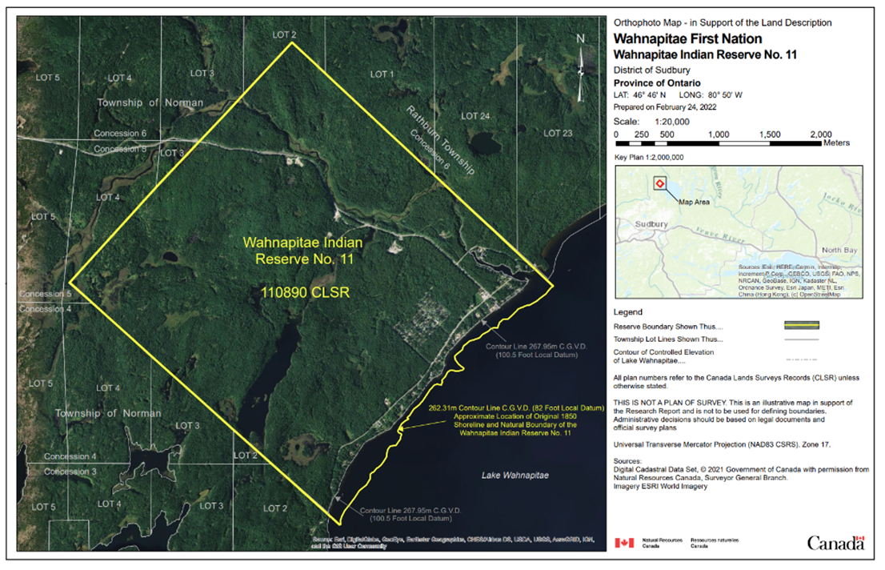


For more information, please contact Katie Ede, Lands and Resources Assistant at katie.ede@wahnapitaefn.com or by phone (705)858-0619
www.wahnapitaefirstnation.com

